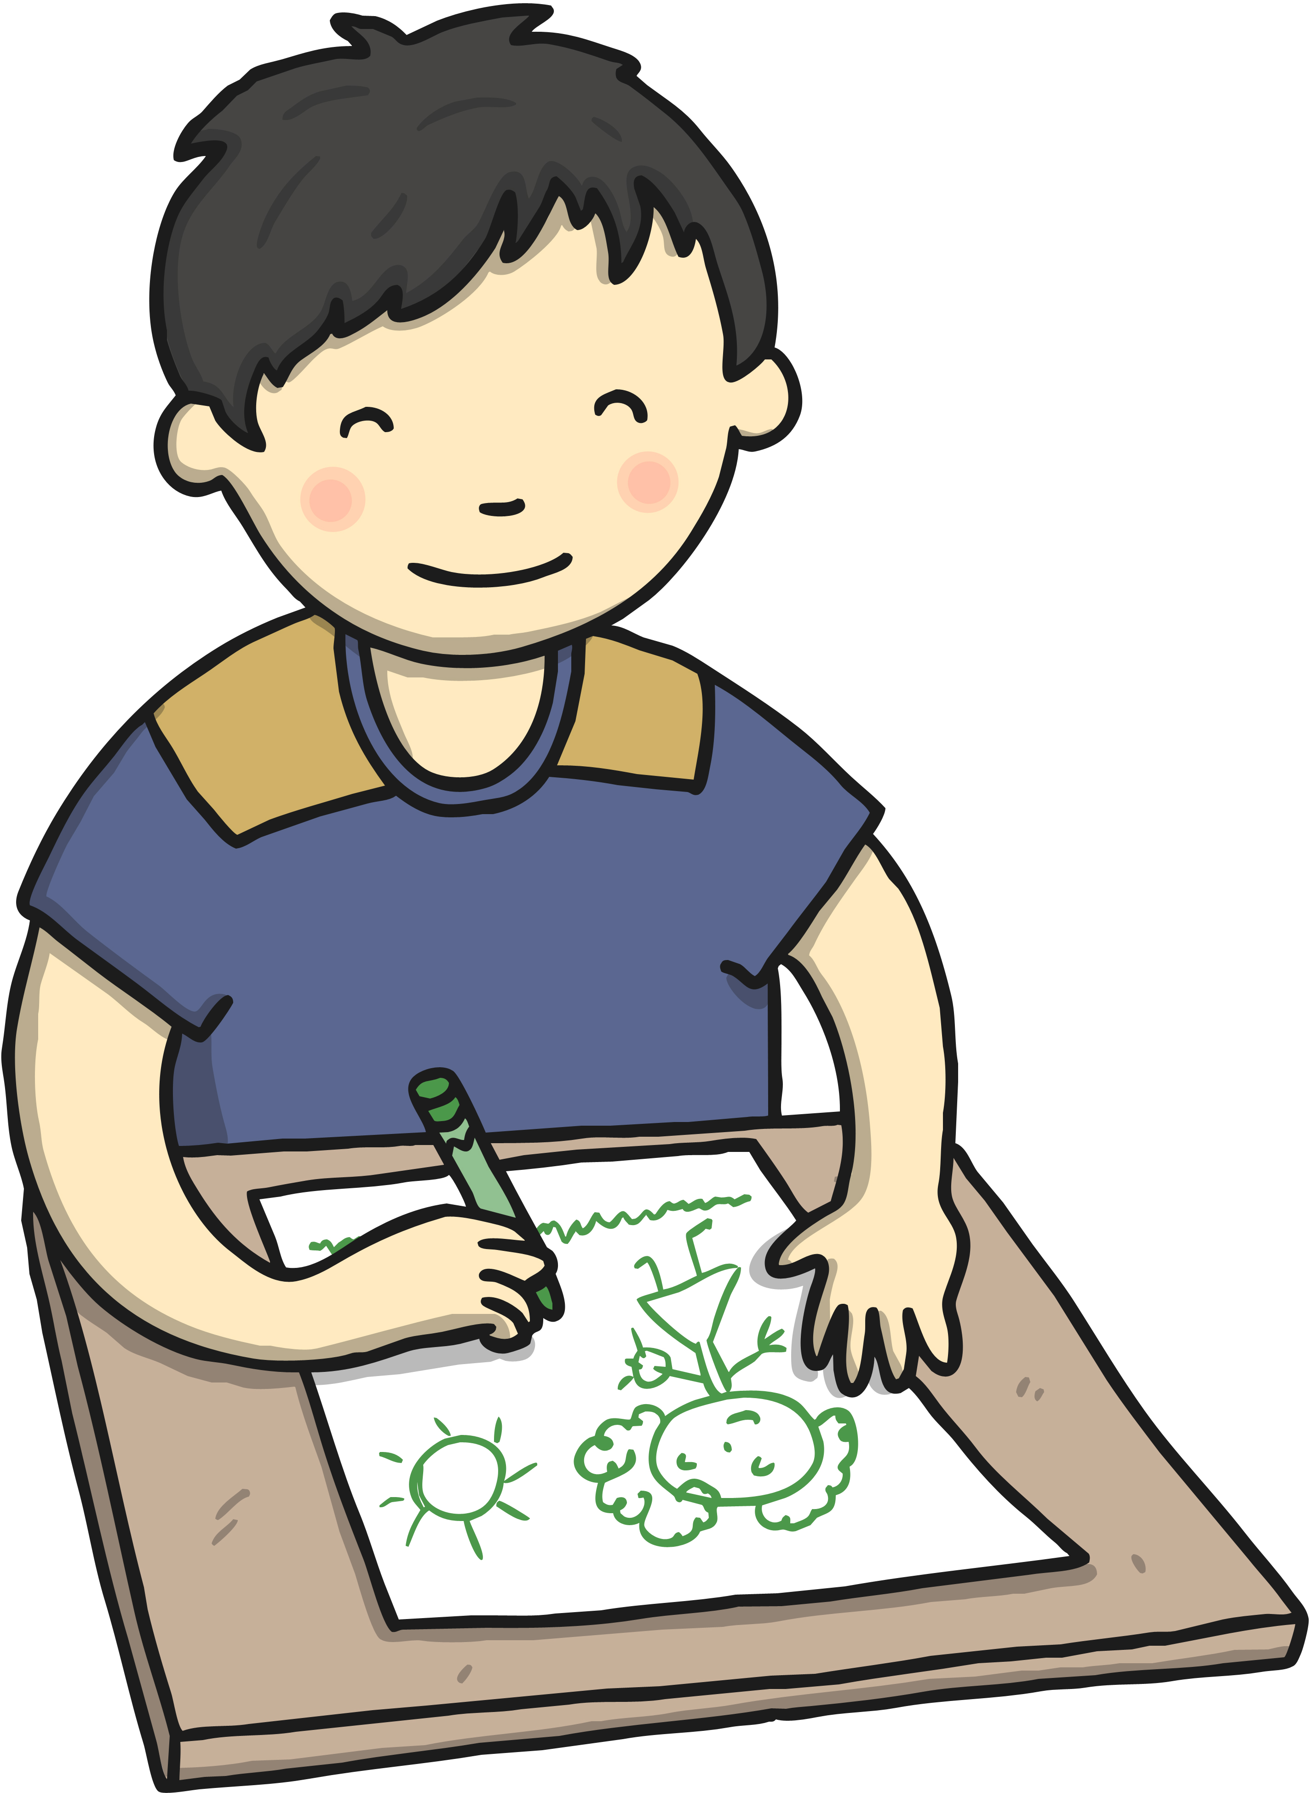
CMBC Preschool Newsletter
September 2023
Welcome back!
We hope you’ve had a lovely summer break! During our first weeks back, we will be concentrating on settling the children back into our routines and then we will begin our first topic ‘All About Me’. We will be focusing on our families, our senses and the environment around us. We would love if you could bring in a picture of your child and their family for our display board.
Notices  - As always, please make sure that all coats, bags, hats and gloves have your child’s name inside.  - Keyworkers continue to upload daily photos, observations and assessments to your child’s ParentZone account. Please let Aimee know if you are having difficulties logging into your account or if you have forgotten your password. | Important Dates  Mon 2nd Oct – Grandparent day  Fri 13th Oct – Autumn walk in Ridgeway Park  Fri 20th Oct – End of half term  Mon 30th Oct – Staff INSET (no children)  Tues 31st Oct – Children back to preschool
Special Events /Activities/News
It is ‘Grandparents Day’ on Sunday 1st October and to celebrate we will be inviting any willing grandparents to join us in the setting on Monday 2nd October between 9:30am and 11am! Grandparents are welcome to join in our craft activities and read with the children, as well as having a cup of tea and cake for their time! Please let us know if you will have anyone attending with your child on that morning.
- We are planning an ‘Autumn Walk’ to Ridgeway Park on the morning of Friday 13th October to collect leaves, conkers and acorns. A separate letter with more details will be sent out soon.
- We will be continuing picking children to take our preschool teddy, ‘Cheeky Monkey’, home on the weekends. Parents are encouraged to take photos and write in his ‘diary’ so it can be shared with the other children. If there is a particular weekend you would like your child to have him, please let us know.
Special Request
Could returning parents please have one last look in our lost property box to see if any of the coats/clothes/toys/hairbands belong to your child otherwise they will be reabsorbed into our spare clothes box!
We are trying to use more natural materials in the setting for children to use and explore during their learning activities. If you are able to find any of the following while out and about at the weekend, we would greatly appreciate them in the setting!
Interesting leaves, large stones and pebbles, flowers, grass, twigs, bark, conkers, acorns, pine cones, shells, cotton reels, yarn, fabric scraps,

