**March 2025**

**Dear Parents and Carers**

**We hope you are doing well.**

**Our visit to Chingford Fire Station which took place on Tuesday 18Th March**

**We were grateful for the lovey weather. The fireman made us very welcome. All the children had a lovely time and some of the parents did too. Thank you for supporting us with this trip.**

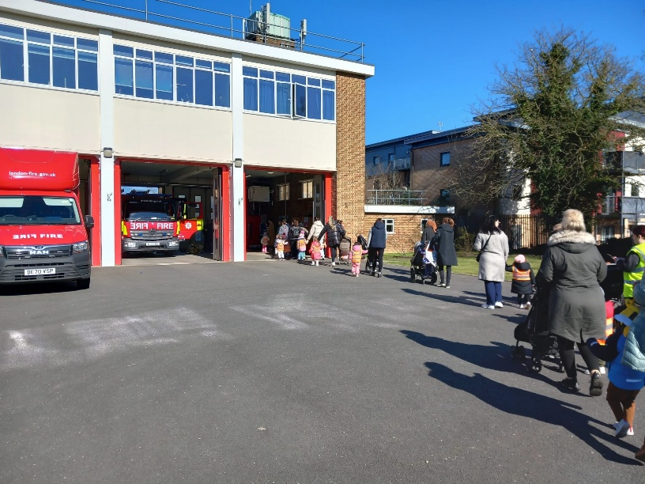

**Celebrating happening and dates the remained of our Spring term 2025.**

**We will be celebrating Mother Day and Edi next Friday 28 March 2025 in the nursery at 10:30am and we would to invite all the mum to come and join with us. If you have any question please speak with Bushra.**

**Our Easter celebration will take place on Wednesday 2nd April at 9:30am in our church Hall. We would like to invite all the parent to join with us.**

**Saying Goodbye**

**Our deputy manager Sophie is sadly leaving us and her final day will be Friday 4 April the last day of term.**

**A few reminders.**

**If you child is still using nappies, please can you provide them along with wipes**

**Healthy pack lunch: These have much improved but we would like to remind you again of the importance of a health pack lunch so please no chocolates, crisps or juices.**

**Important Reminder of Term Dates**

**The end of spring term is Friday 4 April at 2pm**

**Preschool Inset Day is Tuesday 22 April 2025 (Nursery Closed)**

**We reopen on Wednesday 23 April 2025**.**at the usually time.**

All the staff term, here hope that you have a great Easter break and look forward to see you again on Wednesday 23rd April 2025